**BEFORE THE DISTRICT CONSUMER DISPUTES REDRESSAL COMMISSION, MUMBAI**

**Consumer Complaint No. ____ of 2025**

**IN THE MATTER OF:**  
Pratik Shah — Complainant

Versus  
**Opposite Parties:**

1. **Hisense India Pvt. Ltd.**
2. **Toshiba India Pvt. Ltd.**
3. **Toshiba Authorized Service Center (Reliance ResQ – Synergy Electronics)**

**Photo 1** : Image of the issue with the television where you see the right side of the screen is blank and top left you see the picture

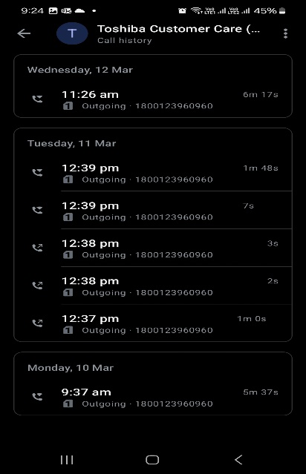

**Photo 2 :** Call logs made to Toshiba customer service shows we raised complaint on 10 March 2025. It also shows most of the time number was not available.

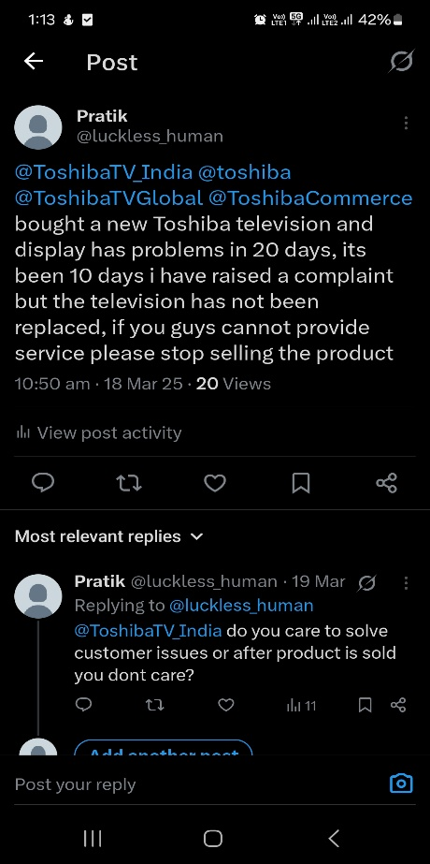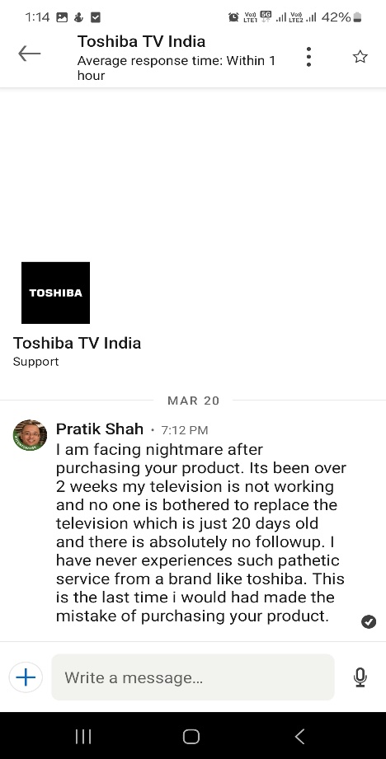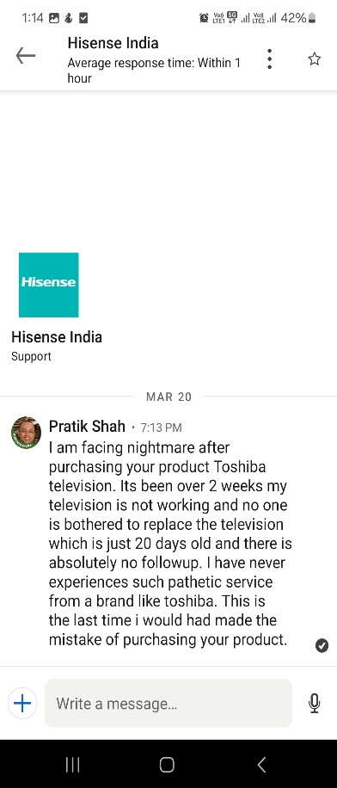

**Photo 3:** Complaint raised via social media, but no response.

r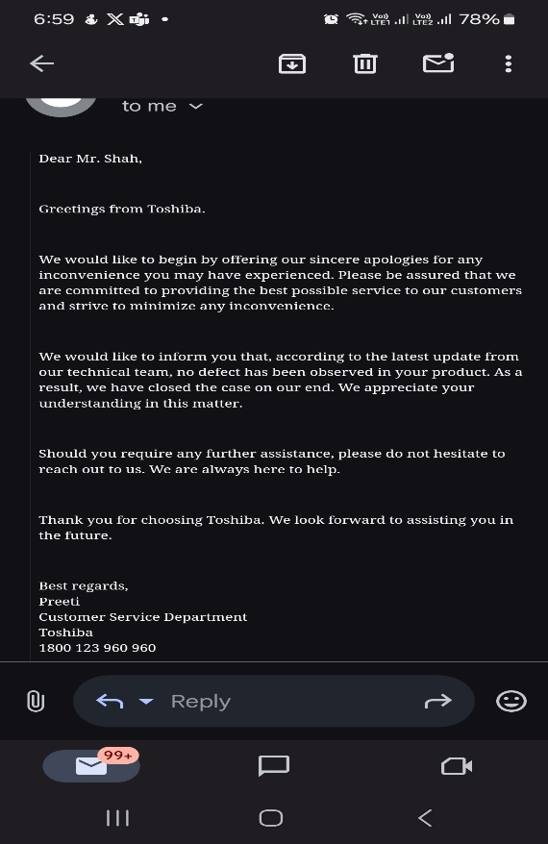

**Photo 4:** Left they acknowledge the issue, right they deny there is any issue.

**Photo 5:** Call logs from Hisense customer care team and imtiyas from the service center.